Deploy NGINX with helm accordingly:

- Deploy nginx application with 3 replicas, after few minutes add 2 more replicas

- Check the dashboard to see the replicas count change

- Configure mail alerts and fire an alert.

<https://docs.nginx.com/nginx-ingress-controller/installation/installation-with-helm/>

helm repo add nginx-stable https://helm.nginx.com/stable

helm repo update

helm install my-nginx nginx-stable/nginx-ingress

see the current pods:

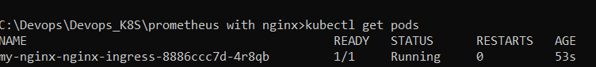

See and copy the default values:

helm show values nginx-stable/nginx-ingress >values.yaml

change the values according needs (for Prometheus, replications and so) and run:

helm upgrade my-nginx nginx-stable/nginx-ingress --values .\values.yaml

Access to Prometheus:

<http://127.0.0.1:9090/>

Connect to Gtafana:

<http://127.0.0.1:3000/?orgId=1>

Add data source. Go to configuration 🡪 data sources 🡪 add the following:

<http://prometheus-server.monitoring.svc.cluster.local>

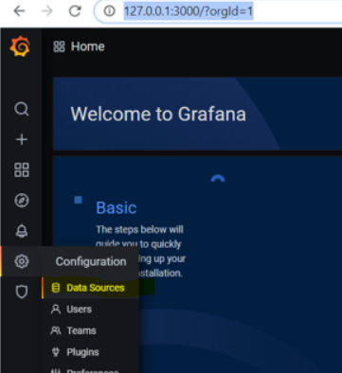

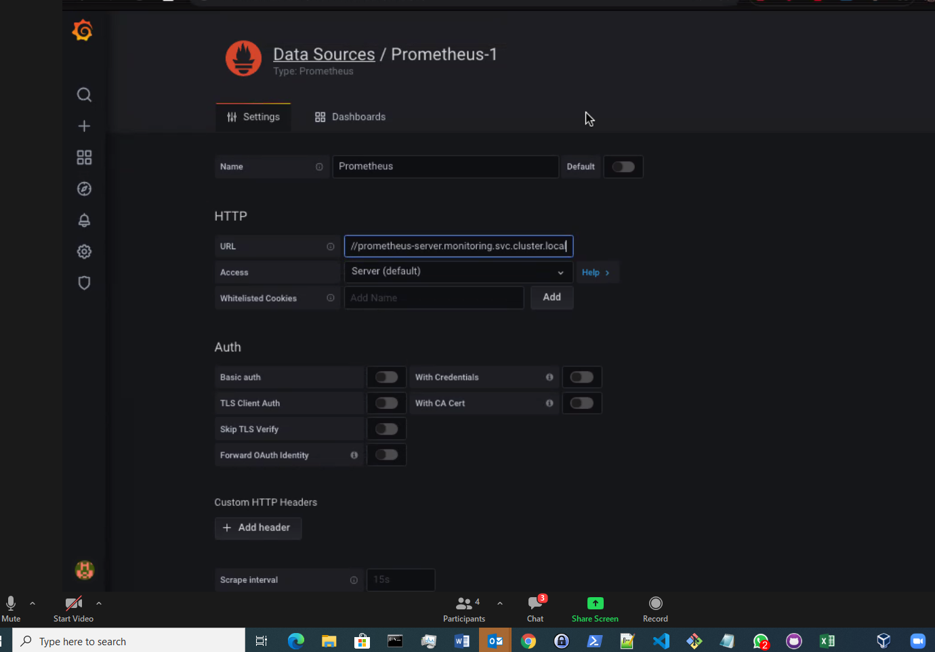

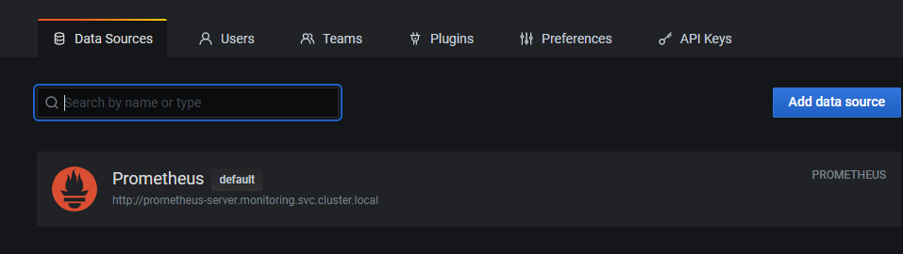

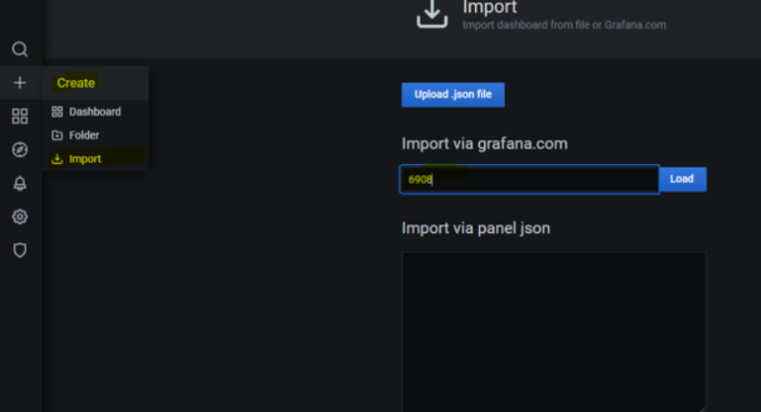

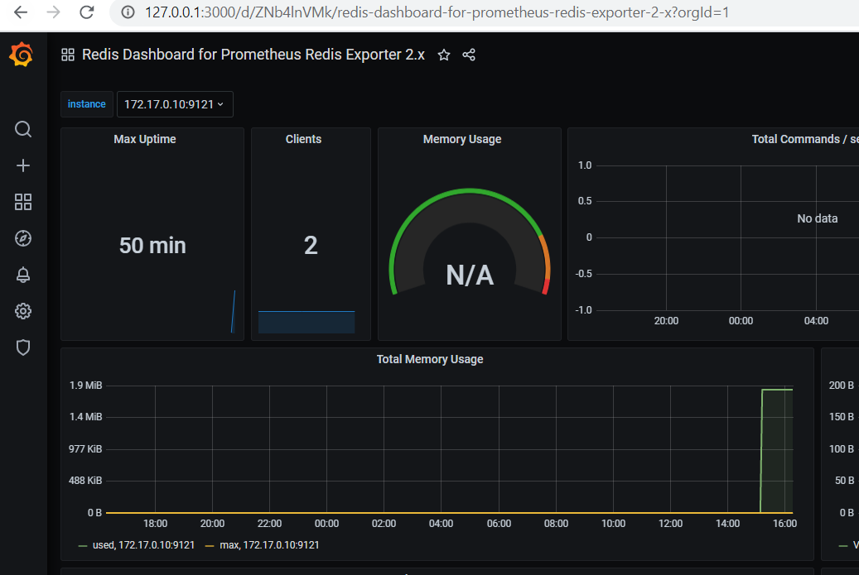

**BONUS1** :K8s dashboard:

<https://grafana.com/grafana/dashboards/6417>

and import it:

